Maths Calculation Strategy Sheet
Our focus is on adding and subtracting a 1 digit number to a 2 digit number within 20 where it does not cross 10s. We will then be looking at numbers within 50 and 100 again where the numbers do not cross 10s.
e.g. 15 + 3 = 17 – 4 = 34 + 3 = 64 – 2 =
- Using a number line
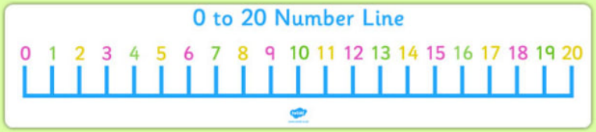

- Using a 100 grid

- Practically using dienes and drawing 10s and 1s.
We use sticks do represent how many tens in a number and dots to represent how many ones are in the number. This is the language that we are using in school.
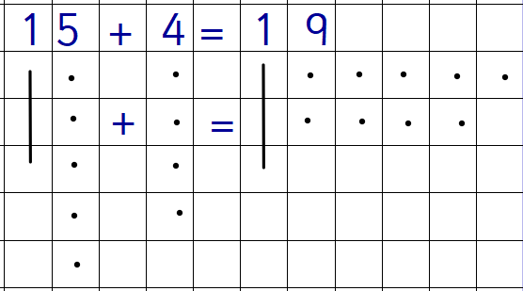
Addition
Write the equation
Draw the number of 10s and 1s
Count and draw the 10s
Count and draw the 1s
Count how much you have altogether
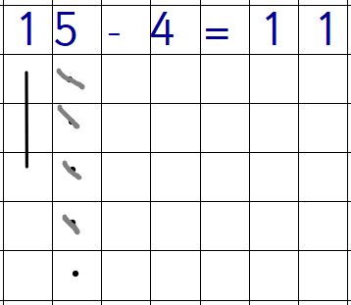

Subtraction
Write the equation
Draw the number of 10s and 1s for your whole
Cross out the amount of 1s your subtracting
Count how much you have left

