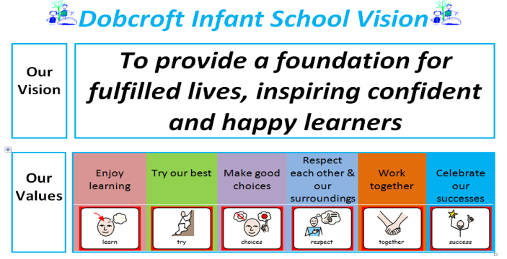
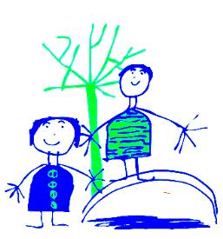
Dobcroft Infant School PE Curriculum Map
Termly Overview and Coverage

Foundation Stage | Autumn | Autumn 2 | Spring 1 | Spring 2 | Summer 1 | Summer 2
Lesson 1  Weekly Dough Disco | Music & Movement  Focus: How to find and use space. | Gymnastics | Gymnastics | Ball Skills | Gymnastics | Games
Planning |  | Rawmarsh Planning | Rawmarsh Planning | Val Salbin | Rawmarsh Planning | Val Sabin / Rawmarsh
Lesson 2 | Movement and Balance – balance bikes  Focus on balancing and body control | Movement and Balance – balance bikes  Focus on balancing and body control | Outside Gross Motor | Balance Bikes  Individual / partner and team games | Gymnastics | Games
Planning |  |  |  |  | Rawmarsh Planning | Val Sabin / Rawmarsh

Year 1 | Autumn 1 | Autumn 2 | Spring 1 | Spring 2 | Summer 1 | Summer 2
Lesson 1  Gymnastics | Focus:  1 Travelling in different ways – different heights and different body parts.  2 Body Shapes – recap strong shapes and narrow and wide body shapes.  3 Evaluate own and others performance looking for examples of control, co-ordination, flexibility, strong core, interesting shapes/balances, working at different levels, different directions.  Work on performing with control and co-ordination.  Apply to apparatus in individual sequences |  | Focus:  1 Balances – different body parts  2 Recap Travelling in different ways and different directions  3 Learning to sequence routines together and to perform and copy sequences.  4 Rock and Roll – start of forwards rolls  5 Evaluate own and others performance as previous  Work on performing with control and co-ordination.  Apply to apparatus in individual sequences |  | Focus:  1 Jumping – 5 basic jumps and on and off apparatus  2 Combining learning in sequences – different levels, balances, jumps, travelling with variations in speed/shape/level.  3 Evaluate own and others performance as previous  Work on performing with control and co-ordination.  Apply all learning to apparatus to create partner or group sequences
Planning | Rawmarsh Planning  Lessons 1 to 7 |  | Rawmarsh Planning  Lesons 8 – 12 |  | Rawmarsh Planning  Lessons 13 – 16
Lesson 2  Games / Dance  (3 x Games)  (2 x Dance)  (1x swimming) | Games  Focus:  Skills based  Patting and bouncing balls  Throwing / catching  Rolling / receiving  Kicking / dribbling  Warm up – skills baskets | Dance  Focus:  To copy and repeat a sequence of 3 actions with clear start, middle and finish.  Perform in a controlled manner. | Games  Focus:  Team Games  Developing skills from Term 1 and simple tactics for attacking and defending.  Warm up – skills baskets  Striking and Fielding Game | Swimming  + Outdoor PE  Skipping  (4 lessons)  Must be outside | Games  Focus:  Team Games  Developing skills from Term 1 and simple tactics for attacking and defending.  Warm up – skills baskets  Net Game | Dance (spring 2 if swimming)  Focus:  Compose and link movement phrases to make simple dances with clear beginning, middle and end.  Perform in a controlled manner.
Planning | Val Sabin – Year 1 Unit 1 | iMoves –  Use lesson plans | Rawmarsh – Merry Go Round Game  Skills development – Val Sabin (if required) | British Heart Foundation  Lesson 1 – 4 | Rawmarsh - Hoopla  Skills development – Val Sabin (if required) | IMoves –  Use lesson plans

Year 2 | Autumn 1 | Autumn 2 | Spring 1 | Spring 2 | Summer 1 | Summer 2
Lesson 1  Gymnastics | Focus:  1 Travelling – working at different levels  2 Working with partner  3 Balancing on different body parts  1x lesson on mats – rolls  Different rolls – pencil, tuck, teddy bear, forwards rolls (can apply to wedges and benches if secure on floor).  Evaluate own and others performance looking for examples of control, co-ordination, flexibility, strong core, interesting shapes/balances, working at different levels, different directions.  Apply to apparatus in individual sequences |  | Focus:  1 Different pathways for travel – individually and following/alongside partner  2 Creating individual and partner sequences  3 Performing with control and co-ordination a routine using 3 actions  Evaluate own and others performance as previous  Apply to apparatus in individual sequences |  | Focus:  1 Jumps – for height and 5 basic jumps with control  2 Quarter turns and half turns  Including applying these to sequences with previous learning  Evaluate own and others performance as previous  Apply all learning to apparatus to create partner or group sequences
Planning | Rawmarsh Planning  Lesson 1 – 6 |  | Rawmarsh Planning  Lesson 7 - 11 |  | Rawmarsh Planning  Lesson 12 – 16
Lesson 2  Games / Dance | Games  Focus:  Skills based  Throwing / catching  Warm up – skills baskets | Dance  Focus:  Develop fundamental skills and become increasingly confident and competent.  Access a broad range of opportunities to extend agility, balance and co-ordination. | Games  Focus:  Team Games  Participate in competitive physical activities against self and others.  Develop simple tactics for attacking and defending.  Understand simple rules  Warm up – skills baskets  Striking and Fielding Game – extend skills using batting | Dance  Focus:  Link several movements together with control and co-ordination.  Perform dances using simple movement patterns.  Compose and perform dance phrases individually/pairs/  groups | Games  Outdoor  Skipping  (4 lessons)  Must be outside | Games  Focus:  Team Games  Participate in competitive physical activities against self and others.  Develop simple tactics for attacking and defending.  Understand simple rules  Warm up – skills baskets  Invasion Game
 | Val Sabin – unit 1 | i Moves –  use lesson plans | Rawmarsh – Bean Bag Drop  Lessons 1 – 4 | i Moves –  use lesson plans | British Heart Foundation  Lessons 3 – 6 | Rawmarsh – Touch Down  Lesson 1 – 4
PE Assessment tool info
Foundation Stage |  | Fundamental Skills Covered  General: Pupils can look, listen and follow simple verbal and body signals and instructions.  Pupils can dress and undress independently  Can be physically active for 10 minutes without needing a break. | Opportunities for competition  Timing how long it takes to change for PE  Looking at which groups can change the fastest  Can the class beat their changing time
 | Dance | Pupils can move to music showing basic rhythm and timing.  Pupils can copy and repeat a simple set of movements.  Pupils can demonstrate moving with rhythm and control.  Pupils can begin to perform some simple dance moves.
 | Gymnastics | Shapes – wide, narrow, tall, small shapes  Can crawl in opposition with flat hand base, with fingers and thumbs together and extended pointed feet.  Show control when travelling  Show travelling with co-ordination on both floor and apparatus  Jumps and lands appropriately  Can stop with a firm base, strong core and clear shape on a signal whilst travelling
 | Movement and Balance

