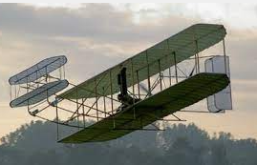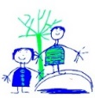DIS Year 2

**Other Curriculum Areas:**

**PE:** games and First Aid

**PSHE:** What makes a good citizen?

**DT:** Using axles and wheels through making an aeroplane.

**Art**: Different art styles and artists from around the world with a focus on pointillism and Hubaina Limid.

**RE:** Leaders from different religions with a focus on Christianity.

**Music**: Learning how to play a tuned instrument (violins) and use their voices expressively by singing songs and speaking chants. They will also be learning about different instruments.

**Metacognition**: Learning how to sign our name.

**Computing** – We will be learning about Information Technology with a focus on its uses within school, home and beyond.

**History**

We will be exploring the development of the aeroplane, how it has changed over the years and the impact these advancements have had on the world today. This is linked to our literacy text, ‘Emma Jane’s Aeroplane’ and our journey around the continents of the world in Geography.

**Star Words:**

Aeroplane, inventor, travel, differences, chronological.

**Key Knowledge:**

Use information to describe the past.

Describe the differences between then and now.

**Science:**

We will be identifying different habitats from around the world and exploring the different types of animals that live there.

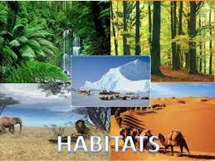

**Star Words:**

Habitat, micro habitat, adapted, polar, desert, rainforest, ocean, woodland.

**Key Knowledge:**

Identify that most living things live in habitats to which they are suited.

**Autumn 1 - Location, Location, location**

**Geography**

We will be learning about different countries and continents around the world. Learning about their food, culture and populations.

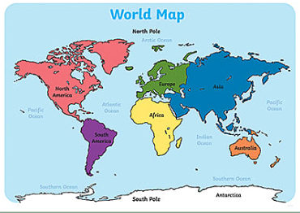

**Star Words:**

Continents, Europe, Africa, Asia, North America, South America, Australia, Antarctica.

**Key Knowledge:**

Know the names of and locate the seven continents of the world.