Bird from the Egg
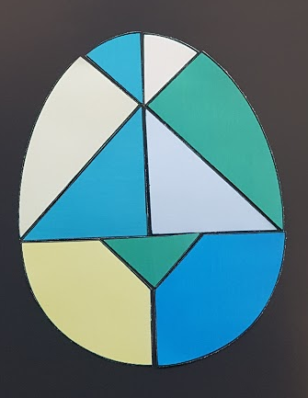
Cut out the shapes from the egg. Use the shapes to create the bird pictures below. Can you create a bird of your own? Take your creations to Mrs Cooke in Rabbit classroom, or email them to cookeb@dobcroft-inf.sheffield.sch.uk.
