Go to the DobcrofC:\Users\class4\AppData\Local\Microsoft\Windows\Temporary Internet Files\Content.IE5\DRHR3KGC\190917401[1].gifC:\Users\class4\AppData\Local\Microsoft\Windows\Temporary Internet Files\Content.IE5\2J79M225\190917401[1].gifC:\Users\class4\AppData\Local\Microsoft\Windows\Temporary Internet Files\Content.IE5\DRHR3KGC\190917401[1].gifC:\Users\class4\AppData\Local\Microsoft\Windows\Temporary Internet Files\Content.IE5\2J79M225\190917401[1].gift summer faC:\Users\class4\AppData\Local\Microsoft\Windows\Temporary Internet Files\Content.IE5\DRHR3KGC\190917401[1].gifC:\Users\class4\AppData\Local\Microsoft\Windows\Temporary Internet Files\Content.IE5\2J79M225\190917401[1].gifC:\Users\class4\AppData\Local\Microsoft\Windows\Temporary Internet Files\Content.IE5\DRHR3KGC\190917401[1].gifC:\Users\class4\AppData\Local\Microsoft\Windows\Temporary Internet Files\Content.IE5\2J79M225\190917401[1].gifir!



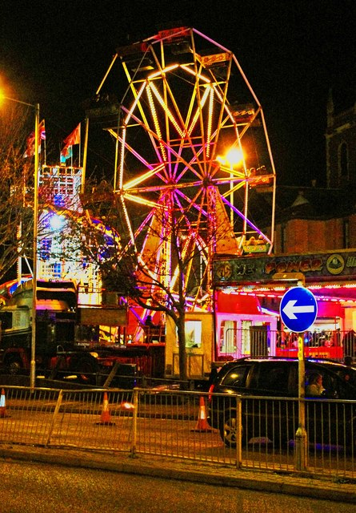C:\Users\class4\AppData\Local\Microsoft\Windows\Temporary Internet Files\Content.IE5\DRHR3KGC\livros[1].gifC:\Users\class4\AppData\Local\Microsoft\Windows\Temporary Internet Files\Content.IE5\2J79M225\190917401[1].gifC:\Users\class4\AppData\Local\Microsoft\Windows\Temporary Internet Files\Content.IE5\2J79M225\190917401[2].gif

Saturday 1st july 12pm till 4pm.

Have fun on the day of the summer fair!