Come to dobcroft summer fair.
Saturday 1 july 12 pm until 4pm
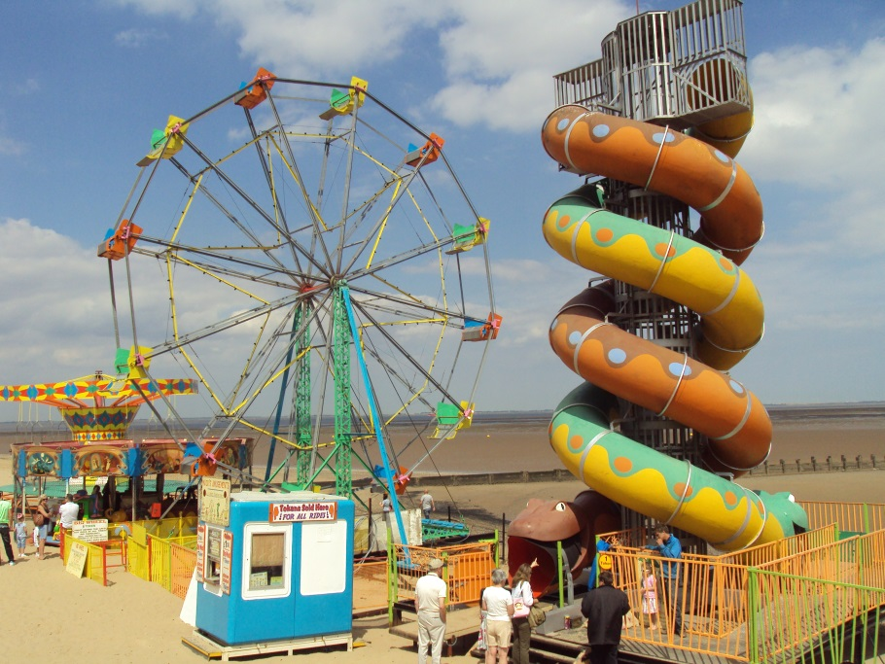

Theo George

