Come to the summer fair!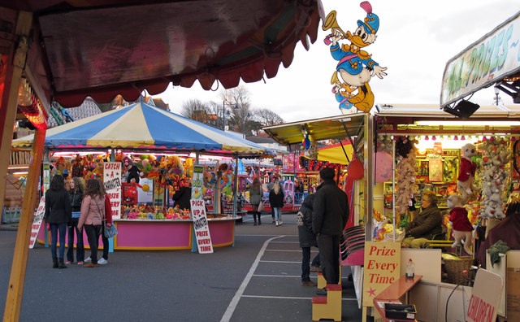
Saturday 1th July 12pm until 4pm

Sabeehah ISABELLE

