COME TO THE DOBCROFT SUMMETR FAIR.
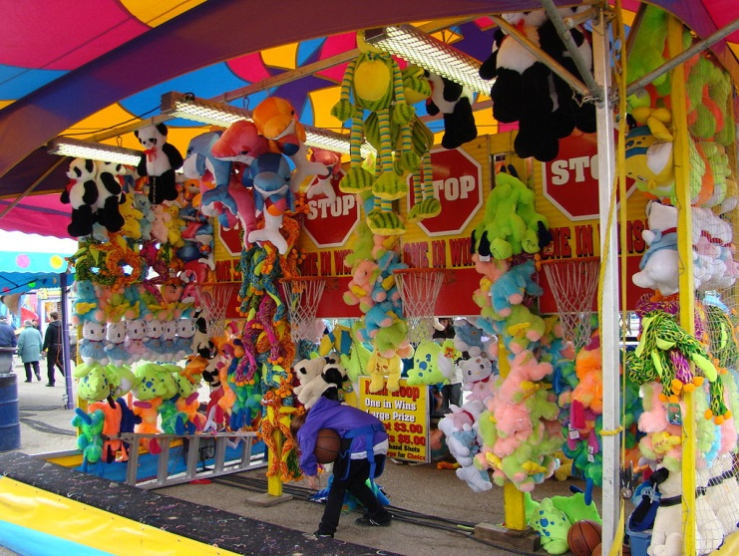

Saturday 1st July 12pm until 4pm .

Ruby Sophie

