Come to the summer fair
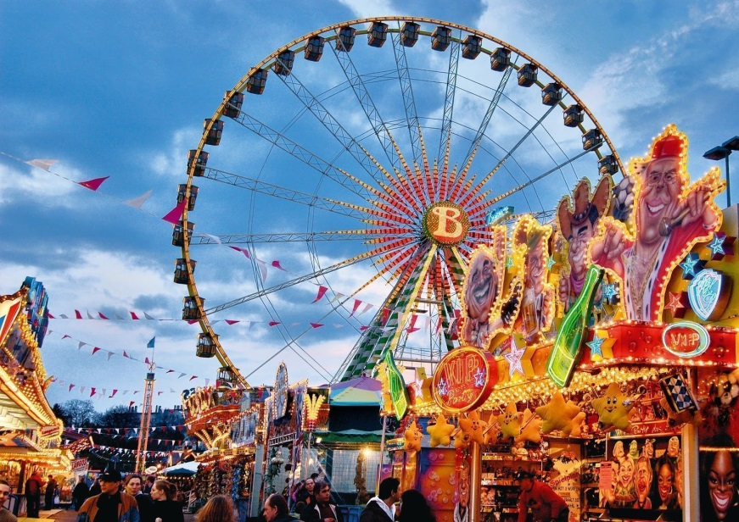

Saterday 1st guly 12pm until 4pm
MIKHAIL SAM

