Come to the dobcroft summer fair!

C:\Users\class4\AppData\Local\Microsoft\Windows\Temporary Internet Files\Content.IE5\TSB9G6V4\11_46_21---Fairground_web[1].gifC:\Users\class4\AppData\Local\Microsoft\Windows\Temporary Internet Files\Content.IE5\TSB9G6V4\11_46_21---Fairground_web[1].gif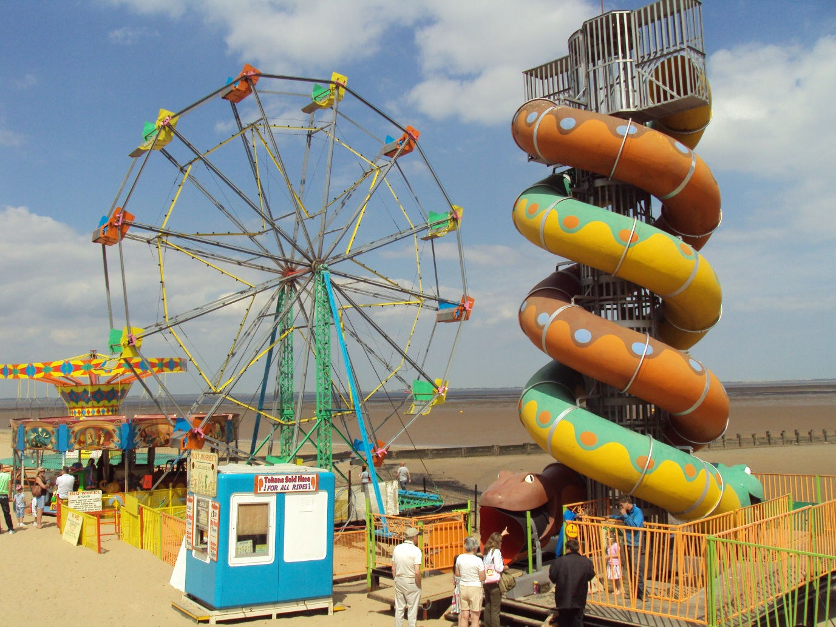

Saturday 1st july 12pm until 4pm

Harry isaac