Come to the Dobcroft summer fair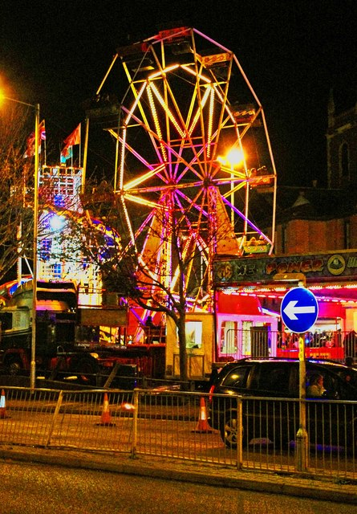
Saturday 1st July
12pm until 4pm
Daniel Harrison

