Apply for a Blue Peter Green Badge
We have a new and exciting way for you to apply for your Blue Peter Green Badge and become a Blue Peter Climate Hero. Follow the steps below to earn your Green Badge. Or, if you've already got a Green Badge, inspire your class or group to get involved and earn yourself a BP Climate Heroes Certificate. Applicants must be 6 to 15 years old.

The three steps:
Three Pledges
Choose your Power, Plastic and Plants Pledges.
Two Weeks
Keep doing the pledges for two weeks.
One Green Badge
Tell us all about your three pledges and apply for your Blue Peter Green Badge!
Please click the link below to find out more info:

https://www.bbc.co.uk/cbbc/findoutmore/blue-peter-apply-for-a-green-badge
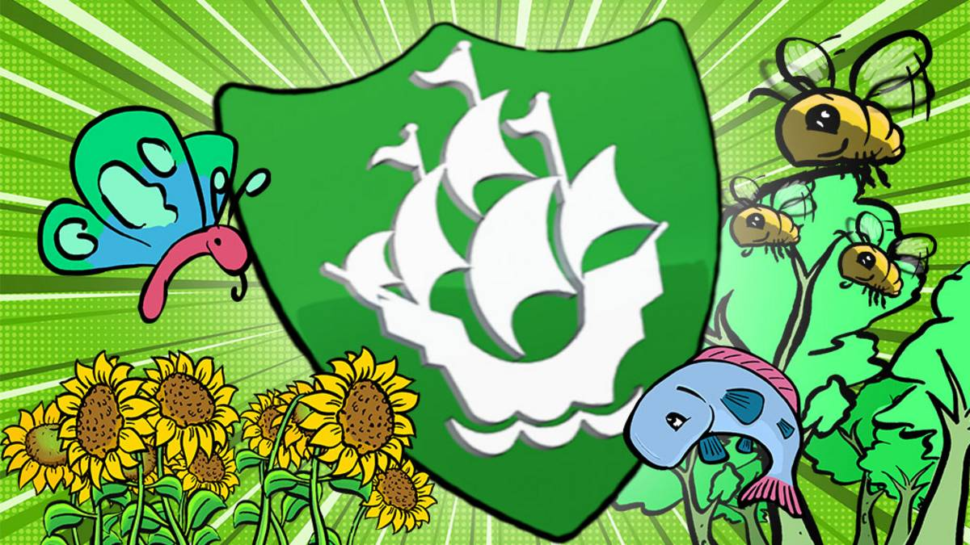
Many thanks
DIS

