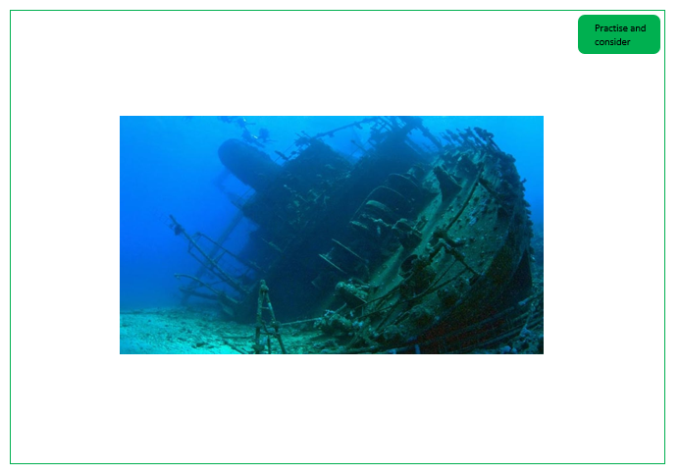

What could have happened to the people on the ship?

Could there be any creatures living in the wreck?

What could the diver hear, see, smell, touch?

How could the diver be feeling when they are looking around?

What might have happened to the boat?

How long has the boat been there for?